**Report “Lab 3”**

**Anton Tserakhau**

# Business analyses tasks – Reports

## Export Geo Location Reference

I have exported Geo Location Reference on Denormalized table:

SELECT

--country

table_hier.country_geo_id as country_geo_id

, cntr.country_id

, CNTR.COUNTRY_CODE_A2

, cntr.country_code_a3

, cntr.region_desc AS country_desc

--region

, NVL ( table_hier.region_geo_id, -99 ) AS region_geo_id

, NVL ( reg.src_continent_id, -99 ) AS region_id

, NVL ( reg.region_code, 'n.d.' ) AS region_code

, NVL ( reg.region_desc, 'n.d.' ) AS region_desc

-- part

, NVL ( table_hier.part_geo_id, -99 ) AS part_geo_id

, NVL ( part.part_id, -99 ) AS part_id

, NVL ( part.part_code, 'n.d.' ) AS part_code

, NVL ( part.part_desc, 'n.d.' ) AS part_desc

-- geo_systems

, NVL ( table_hier.system_geo_id, -99 ) AS geo_system_geo_id

, NVL ( g_sys.src_geo_system_id, -99 ) AS geo_system_id

, NVL ( g_sys.geo_system_code, 'n.d.' ) AS geo_system_code

, NVL ( g_sys.geo_system_desc, 'n.d.' ) AS geo_system_desc

-- sub_groups

, NVL ( table_hier.sub_group_geo_id, -99 ) AS sub_group_geo_id

, NVL ( sub_grp.sub_group_id, -99 ) AS sub_group_id

, NVL ( sub_grp.sub_group_code, 'n.d.' ) AS sub_group_code

, NVL ( sub_grp.sub_group_desc, 'n.d.' ) AS sub_group_desc

-- groups

, NVL ( table_hier.group_geo_id, -99 ) AS group_geo_id

, NVL ( grp.GROUP_ID, -99 ) AS GROUP_ID

, NVL ( grp.group_code, 'n.d.' ) AS group_code

, NVL ( grp.group_desc, 'n.d.' ) AS group_desc

-- group system

, NVL ( table_hier.group_system_geo_id, -99 ) AS group_system_geo_id

, NVL ( grp_sys.grp_system_id, -99 ) AS group_system_id

, NVL ( grp_sys.grp_system_code, 'n.d.' ) AS group_system_code

, NVL ( grp_sys.grp_system_desc, 'n.d.' ) AS group_system_desc

--

FROM ( SELECT country_geo_id

, SUM ( region_geo_id ) region_geo_id

, SUM ( part_geo_id ) part_geo_id

, SUM ( system_geo_id ) system_geo_id

, SUM ( sub_group_geo_id ) sub_group_geo_id

, SUM ( group_geo_id ) group_geo_id

, SUM ( group_system_geo_id ) group_system_geo_id

FROM ( SELECT DISTINCT

CONNECT_BY_ROOT ( links.child_geo_id ) country_geo_id

, links.parent_geo_id

, links.link_type_id

, CASE WHEN ( links.link_type_id = 3 ) THEN links.parent_geo_id ELSE NULL END AS region_geo_id

, CASE WHEN ( links.link_type_id = 2 ) THEN links.parent_geo_id ELSE NULL END AS part_geo_id

, CASE WHEN ( links.link_type_id = 1 ) THEN links.parent_geo_id ELSE NULL END AS system_geo_id

, CASE WHEN ( links.link_type_id = 6 ) THEN links.parent_geo_id ELSE NULL END AS sub_group_geo_id

, CASE WHEN ( links.link_type_id = 5 ) THEN links.parent_geo_id ELSE NULL END AS group_geo_id

, CASE WHEN ( links.link_type_id = 4 ) THEN links.parent_geo_id ELSE NULL END

AS group_system_geo_id

, LEVEL

FROM w_geo_object_links links

CONNECT BY PRIOR links.parent_geo_id = links.child_geo_id

START WITH links.child_geo_id IN (SELECT DISTINCT geo_id

FROM cu_countries)

ORDER BY country_geo_id)

GROUP BY country_geo_id) table_hier

LEFT JOIN u_dw_references.cu_countries cntr

ON cntr.geo_id = table_hier.country_geo_id

LEFT JOIN u_dw_references.cu_geo_regions reg

ON reg.geo_id = table_hier.region_geo_id

LEFT JOIN u_dw_references.cu_geo_parts part

ON part.geo_id = table_hier.part_geo_id

LEFT JOIN u_dw_references.cu_geo_systems g_sys

ON g_sys.geo_id = table_hier.system_geo_id

LEFT JOIN u_dw_references.cu_cntr_group_systems grp_sys

ON grp_sys.geo_id = table_hier.group_system_geo_id

LEFT JOIN u_dw_references.cu_cntr_groups grp

ON grp.geo_id = table_hier.group_geo_id

LEFT JOIN u_dw_references.cu_cntr_sub_groups sub_grp

ON sub_grp.geo_id = table_hier.sub_group_geo_id

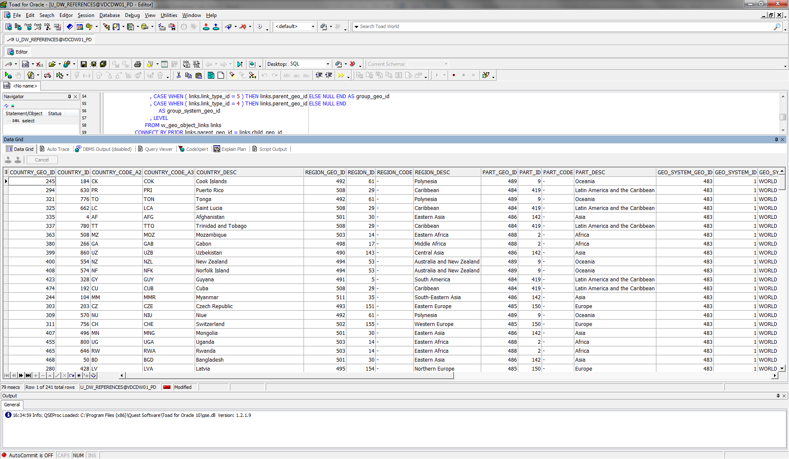

I have added Additional Columns to table:

o Geo_id types: Branch, ROOT, Leaf

o Count of childs of Branch or Root, for Leafs this Field you have fill by NULL

o Full path of Dependencies by Example: ROOT -> BRANCH -> BRANCH -> LEAF

SELECT LPAD ( ' '

, LEVEL * 2

, ' ' )

|| SYS_CONNECT_BY_PATH ( links.child_geo_id

, '/' )

path_with_id

, LPAD ( ' '

, LEVEL * 2

, ' ' )

|| SYS_CONNECT_BY_PATH ( links.description

, '/' )

path_with_names

, links.geo_id

, links.description

, LEVEL

, CASE

WHEN LEVEL = 1 THEN 'ROOT'

WHEN CONNECT_BY_ISLEAF = 1 THEN 'LEAF'

ELSE 'BREANCH'

END

lvl

, ( SELECT COUNT ( * )

FROM t_geo_object_links

CONNECT BY parent_geo_id = PRIOR child_geo_id

START WITH parent_geo_id = links.geo_id )

AS count_of_childs

FROM (SELECT *

FROM ( ( SELECT *

FROM w_geo_object_links )

UNION

( SELECT DISTINCT NULL AS parent_geo_id

, geo_id AS child_geo_id

, NULL AS link_type_id

FROM cu_geo_systems )) idents

LEFT JOIN

( ( SELECT DISTINCT geo_id

, region_desc AS description

FROM cu_countries )

UNION

( SELECT DISTINCT geo_id

, region_desc

FROM cu_geo_regions )

UNION

( SELECT DISTINCT geo_id

, part_desc

FROM cu_geo_parts )

UNION

( SELECT DISTINCT geo_id

, geo_system_code

FROM cu_geo_systems )) names

ON idents.child_geo_id = names.geo_id) links

CONNECT BY PRIOR links.child_geo_id = links.parent_geo_id

START WITH links.parent_geo_id IS NULL;

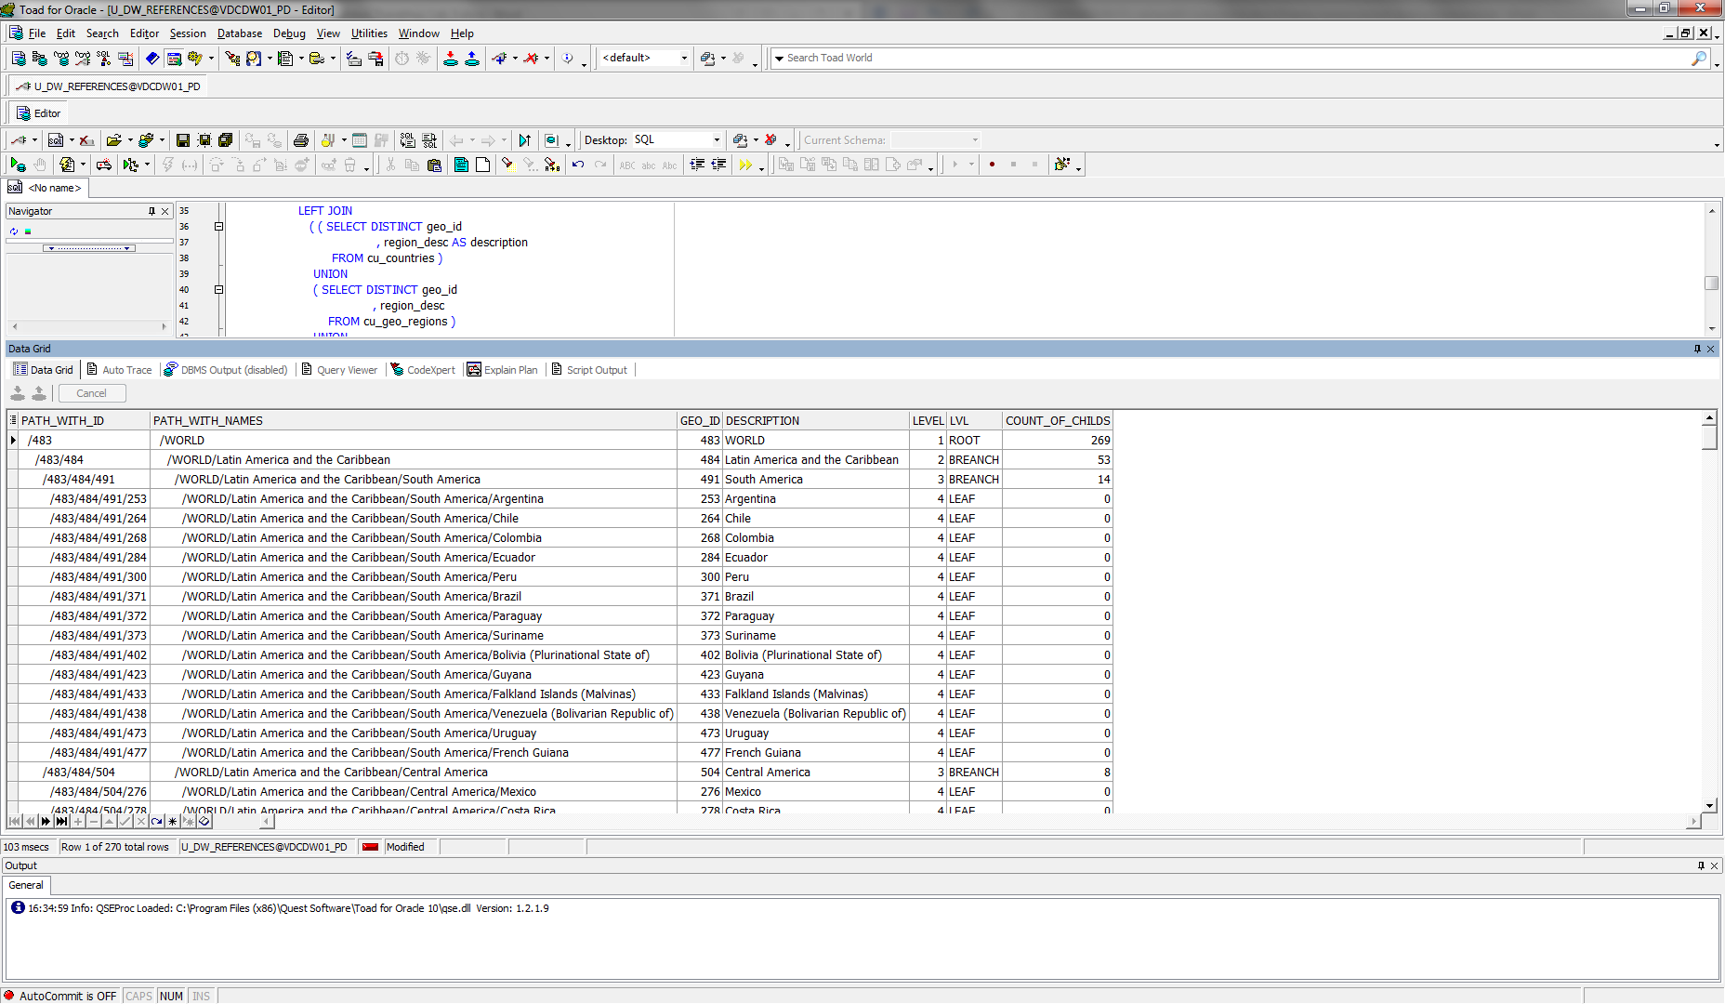

I have created new Schema SB_MBackUp and new Default TableSpace, prepared load script:

CREATE TABLESPACE ts_dw_sb_mbackup_01

DATAFILE 'db_qpt_dw_SB_MBackUp_01.dat'

SIZE 50M

AUTOEXTEND ON NEXT 50M

SEGMENT SPACE MANAGEMENT AUTO;

CREATE USER u_dw_sb_mbackup

IDENTIFIED BY "%PWD%"

DEFAULT TABLESPACE ts_dw_sb_mbackup_01;

GRANT CONNECT,RESOURCE TO

u_dw_sb_mbackup;

ALTER USER u_dw_sb_mbackup QUOTA UNLIMITED ON ts_dw_sb_mbackup_01;

GRANT SELECT ON u_dw_references.w_geo_object_links TO u_dw_sb_mbackup;

GRANT SELECT ON u_dw_references.cu_countries TO u_dw_sb_mbackup;

GRANT SELECT ON u_dw_references.cu_geo_regions TO u_dw_sb_mbackup;

GRANT SELECT ON u_dw_references.cu_geo_parts TO u_dw_sb_mbackup;

GRANT SELECT ON u_dw_references.cu_geo_systems TO u_dw_sb_mbackup;

GRANT SELECT ON u_dw_references.cu_cntr_group_systems TO u_dw_sb_mbackup;

GRANT SELECT ON u_dw_references.cu_cntr_groups TO u_dw_sb_mbackup;

GRANT SELECT ON u_dw_references.cu_cntr_sub_groups TO u_dw_sb_mbackup;

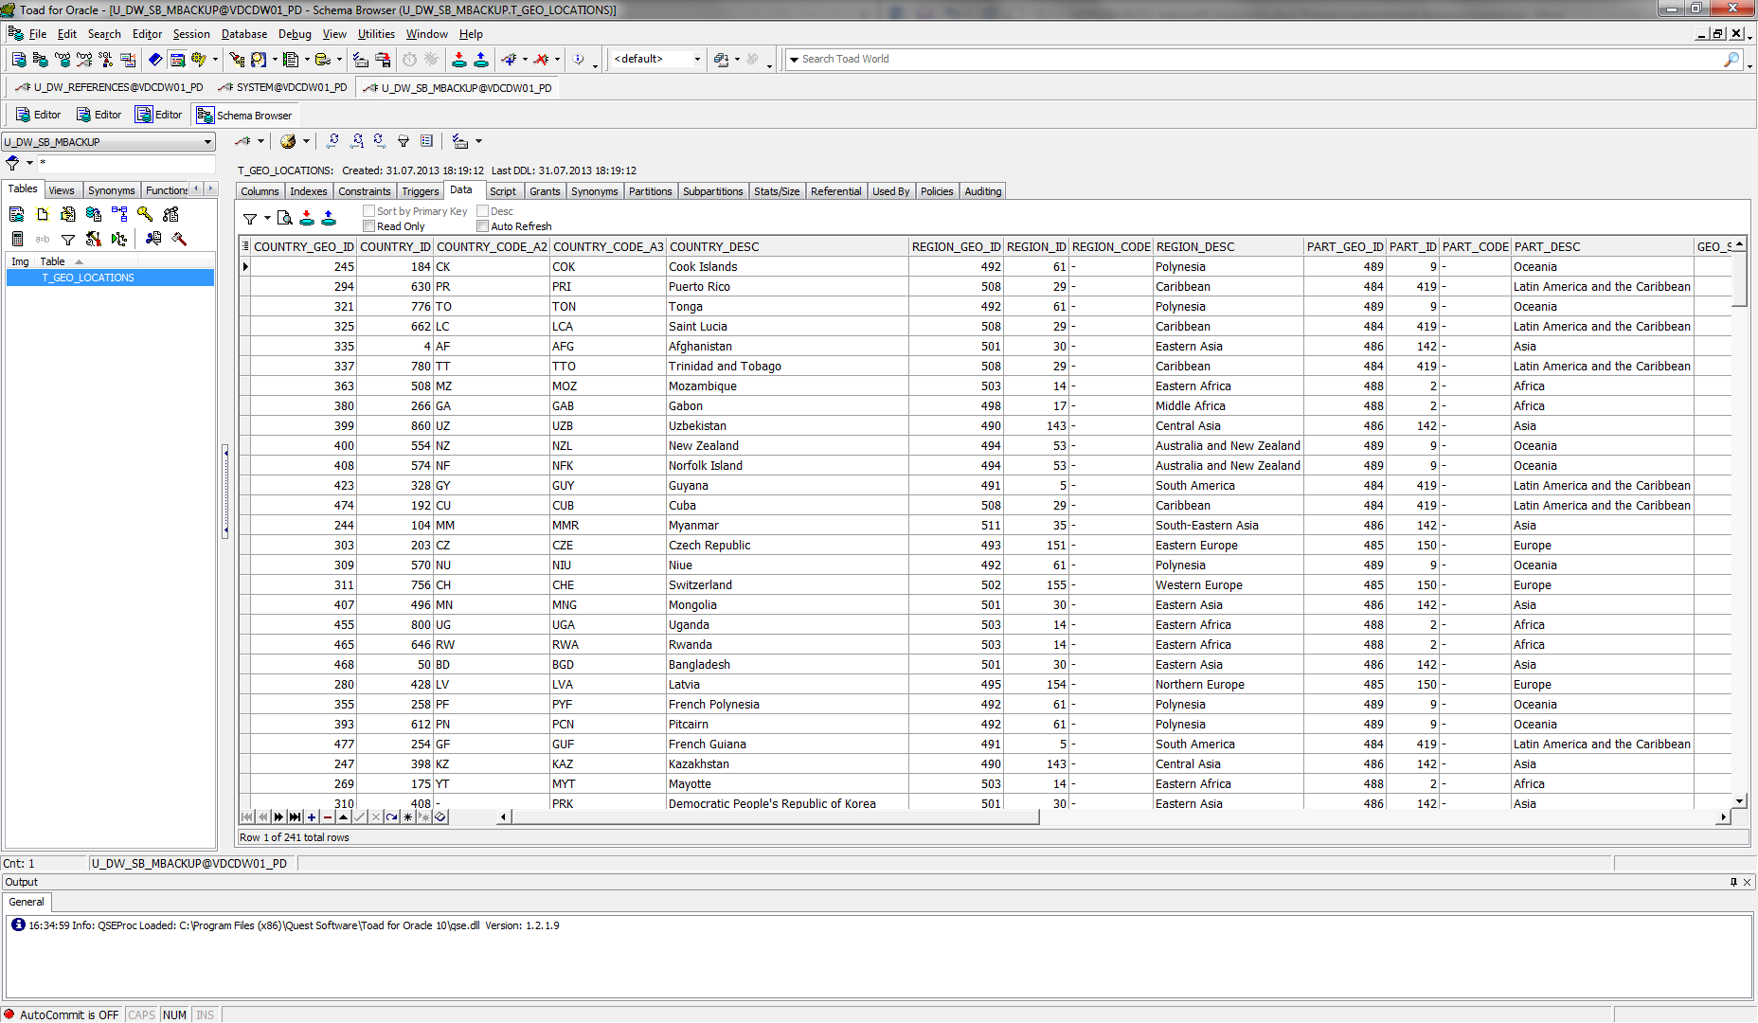

## Task 02: Analyse Business hierarch Reference Analyses

I have added cities into geo_locations scheme.

I have created table LC_CITIES:

Drop table lc_cities;

CREATE TABLE lc_cities

(

geo_id NUMBER ( 22 ) NOT NULL

, city_id NUMBER ( 22 ) NOT NULL

, city_desc VARCHAR2 ( 200 CHAR ) NOT NULL

, localization_id NUMBER ( 22 ) NOT NULL

);

I have inserted data into table LC_CITIES:

INSERT INTO lc_cities

SELECT ROWNUM

+ ( SELECT MAX ( geo_id )

FROM t_geo_objects )

AS geo_id

, ROWNUM AS city_id

, restaurant_city AS city

, 1 AS loc

FROM (SELECT DISTINCT restaurant_city

, restaurant_country_iso_code

, restaurant_country_name

FROM u_dw_ext_references.cls_restaurants) city

LEFT JOIN

cu_countries cntr

ON ( city.restaurant_country_iso_code = cntr.country_code_a2 )

AND ( city.restaurant_country_name = cntr.region_desc );

COMMIT;

I have inserted data into tables T_GEO_TYPES, T_GEO_OBJECTS, T_GEO_OBJECT_LINKS and added partition to table T_GEO_OBJECT_LINKS:

INSERT INTO t_geo_types

VALUES ( 55

, 'CITY'

, 'List all cities' );

INSERT INTO t_geo_objects

SELECT geo_id

, 55

, city_id

FROM lc_cities;

ALTER TABLE t_geo_object_links ADD PARTITION p_city2countries VALUES (7) TABLESPACE ts_references_data_01;

INSERT INTO t_geo_object_links

SELECT DISTINCT cntr.geo_id AS paren_geo_id

, lc_cities.geo_id

, 7 AS lvl

FROM u_dw_ext_references.cls_restaurants city

LEFT JOIN cu_countries cntr

ON ( city.restaurant_country_iso_code = cntr.country_code_a2 )

LEFT JOIN lc_cities

ON lc_cities.city_desc = city.restaurant_city

WHERE cntr.region_desc NOT IN

( 'United States Virgin Islands'

, 'China, Hong Kong Special Administrative Region'

, 'China, Macao Special Administrative Region' );

I have created script with cities

SELECT LPAD ( ' '

, LEVEL * 2

, ' ' )

|| SYS_CONNECT_BY_PATH ( links.child_geo_id

, '/' )

path_with_id

, LPAD ( ' '

, LEVEL * 2

, ' ' )

|| SYS_CONNECT_BY_PATH ( links.description

, '/' )

path_with_names

, links.geo_id

, links.description

, LEVEL

, CASE

WHEN LEVEL = 1 THEN 'ROOT'

WHEN CONNECT_BY_ISLEAF = 1 THEN 'LEAF'

ELSE 'BREANCH'

END

lvl

, ( SELECT COUNT ( * )

FROM t_geo_object_links

CONNECT BY parent_geo_id = PRIOR child_geo_id

START WITH parent_geo_id = links.geo_id )

AS count_of_childs

FROM (SELECT *

FROM ( ( SELECT *

FROM w_geo_object_links )

UNION

( SELECT DISTINCT NULL AS parent_geo_id

, geo_id AS child_geo_id

, NULL AS link_type_id

FROM cu_geo_systems )) idents

LEFT JOIN

( ( SELECT DISTINCT geo_id

, region_desc AS description

FROM cu_countries )

UNION

( SELECT DISTINCT geo_id

, region_desc

FROM cu_geo_regions )

UNION

( SELECT DISTINCT geo_id

, part_desc

FROM cu_geo_parts )

UNION

( SELECT DISTINCT geo_id

, geo_system_code

FROM cu_geo_systems )

UNION

( SELECT DISTINCT geo_id

, city_desc

FROM lc_cities )) names

ON idents.child_geo_id = names.geo_id) links

CONNECT BY PRIOR links.child_geo_id = links.parent_geo_id

START WITH links.parent_geo_id IS NULL;

